**Creating Sheets on the Oracle Solaris Analytics Dashboard**

Oracle Solaris 11.4 introduced with it the Analytics Dashboard. The Oracle Solaris Analytics dashboard enables users to create custom sheets for monitoring and analyzing parameters ranging from performance as well as key StatsStore stats. Here are the steps to follow:

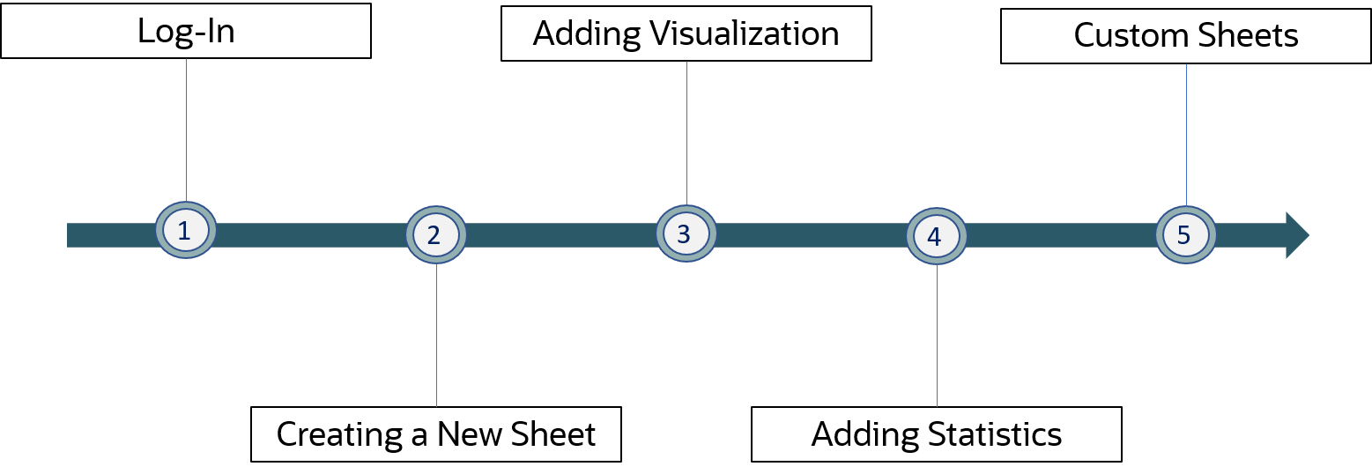

**Step (1): Log-In**

|  |  |  |
| --- | --- | --- |
| **i)** | Login in to the Oracle Solaris Dashboard with your Username and Password |  |
| **ii)** | Oracle Solaris Dashboard with the standard layout |  |

**Step (2): Creating a new sheet**

|  |  |  |
| --- | --- | --- |
| **i)** | Switch to the Solaris analytics tab to see all the available sheets on the dashboard |  |
| **ii)** | Adding a new sheet |  |
| **iii)** | Configuring a new sheet |  |

**Step (3): Adding Visualizations**

|  |  |  |
| --- | --- | --- |
| **i)** | Select the newly created sheet on Solaris analytics |  |
| **ii)** | Adding a new visualization.  A user can also copy a visualization from an existing sheet. |  |

**Step (4): Adding statistics to the new set**

|  |  |  |
| --- | --- | --- |
| **i)** | Select the Add Statistic/Event option under the newly created visualization |  |
| **ii)** | Adding a new statistic  A user may choose to add an existing Stat/Event from another sheet or a configure a new stat/event  (in our case we have used a preexisting stat) |  |
| **iii)** | Choosing a Stat/Event |  |
| **iv)** | Configuring the Stat/Event |  |

**Step (5): Output**

